PhaseSpace motion capture system set up

1. IP Address: 192.168.1.230
2. Subnet: 255.255.255.0
3. Open browser and key in the IP address
   1. Username: admin
   2. Password: phasespace
4. Go to Hub Status tab
   1. Refresh
   2. Check if the 8 camera system is up or not – if not, check connections, power, etc
5. Go to LED Devices tab
   1. 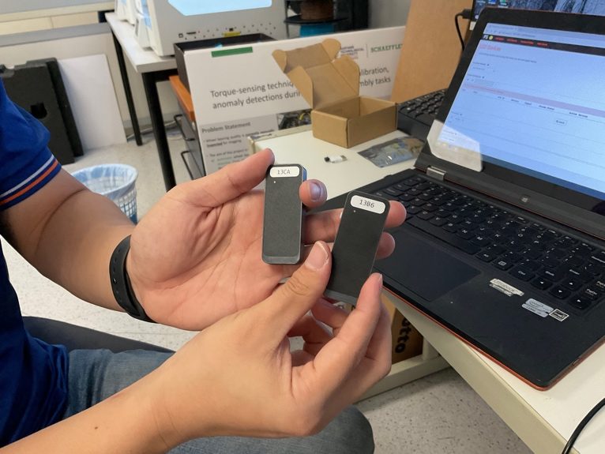You’ll need to see the serial numbers of these drivers
   2. If not, click the eyes icon —> then you’ll see green colour with no LED Devices listed —> Then press the white device button —> then each device will be registered on the portal
      1. Solid blinks – turn on
      2. After holding the white button for three seconds, the device will start blinking faster and then it is ready and discoverable on the portal
   3. Choose the device you want to use for calibration and attach that one to your Magic wand and select the gearbox option on the side and click on “enable for calibration”
6. [Alternatively can also Master Client software] But usually Go to Web Clients tab to initiate calibration
   1. Once you fill all the camera squares up in green colour when operating in View 2D mode, you then need to define baseline, x, y axes
7. [Master client software] Go to Tools menu —> Alignment —>

Tips to reposition/reorient cameras

* Condition for calibration – at least two cameras must be able to view the wand at any point of time